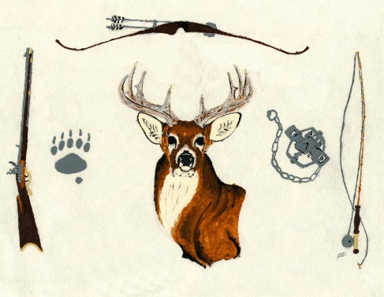

**Conway Sportsman’s Club Scholarship Policy**

All scholarships shall be awarded using the information provided in the enclosed application. Late or incomplete applications will not be considered for an award unless there are extenuating circumstances approved which are approved by the scholarship committee.

Our scholarships are awarded to *any* graduating senior residing within Franklin County. If the graduating senior is a member or his/her family is a member of the Conway Sportsman’s Club, then the residency requirement shall not apply.

Primary consideration will be given to an applicant’s community/school involvement, academic achievements and any work history relative to the completion of the application.

All applications will be reviewed by the Scholarship committee and the chosen applicants shall be notified in early May.

**DEADLINE:** April 20th. Applications postmarked after April 20th will not be considered.

**MAIL:** Your completed scholarship application to:

Conway Sportsman’s Club Scholarship Committee

PO Box 202

Conway MA 01341

**Conway Sportsman’s Club Scholarship Application**

This application contains 3 parts that need to be completed.

1. Provide general information about yourself including your reasons for applying and if you are awarded, how you plan to use your scholarship award**.**
2. Include your school transcript or report completed by your school’s guidance counselor or administrator.
3. Submit a letter of recommendation, the recommendation letter should be written in a professional manner, signed and include the author’s title, business or personal affiliation, how long they have known you and their contact information so the scholarship committee may contact them if needed.

**Part One**

**Name:** ______________________________________________________

**Address:** ____________________________________________________

____________________________________________________

**Email**: ______________________________________________________

**A:** Please tell us the reasons you are applying for this scholarship

and what any awarded monies would be applied towards.

______________________________________________________________

______________________________________________________________

______________________________________________________________

______________________________________________________________

______________________________________________________________

______________________________________________________________

______________________________________________________________

______________________________________________________________

______________________________________________________________

**B:** Please list your school, and extracurricular activities you have been involved in during yourtime in high school. This should include school clubs, sports, theater or band, class offices if held and any committees you may have been involved with. Include any volunteer work you may have done. Provide the duration and academic year for the activities you list. (continue on following page)

______________________________________________________________

______________________________________________________________

______________________________________________________________

**B:** Continued

______________________________________________________________

______________________________________________________________

______________________________________________________________

______________________________________________________________

______________________________________________________________

______________________________________________________________

______________________________________________________________

______________________________________________________________

______________________________________________________________

______________________________________________________________

**C:** List your community work, jobs (summer or after school) or other responsibilities you’ve had during your freshman through senior school years.

______________________________________________________________

______________________________________________________________

______________________________________________________________

______________________________________________________________

______________________________________________________________

_____________________________________________________________

______________________________________________________________

______________________________________________________________

______________________________________________________________

______________________________________________________________

______________________________________________________________

**Part 2**

This part is to be completed by your guidance counselor or school administrator.

Student’s name: __________________________________________

Student’s cumulative grade point average, please use 0.0-4.0 if applicable or a summation if a different grading system is utilized.

Note: If the student has a grade point average available for all four years, please include those otherwise the student’s average to date should be provided.

___________________________________________________________

___________________________________________________________

___________________________________________________________  
___________________________________________________________

Academic Provider: ________________________________________

Name and Title: ___________________________________________

Signature: _________________________________________________

Contact information: _______________________________________

Email: ______________________________________________________

**Part 3**

Please include your recommendation letter by someone who is familiar with you and character and can tell us more about who you are as a person. The letter should be addressed to the Conway Sportsman’s Club Scholarship Committee and included in your application package.

**REMEMBER:** The deadline is postmarked by April 20th.

**Have you:** Completed each part of the application in its entirety parts1-3

Included your transcript from school

Attached your letter of recommendation

Mail your completed application to:

Conway Sportsman’s Club Scholarship Committee

PO Box 202

Conway MA 01341

Best of luck!