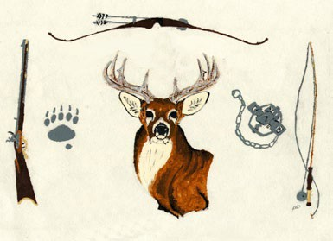
Conway Sportsman’s Club Inc Hold Harmless Release Agreement
2026 Season

I agree to keep safety my number one priority while present and/or participating in any and all events on the Conway Sportsman’s Club properties.
I understand that I can be subjected to loud noises and being hit by target fragments.
I understand that there is a possibility of an occurrence, or an incident of illness and/or injury in a remote place without immediate access to modern medical facilities.
I understand that due to the various forces of nature and acts of God, travel by automobile or other conveyance may be difficult or impossible.
I understand that due to the topography of the Conway Sportsman’s Club, walking or riding on all types of transportation could involve numerous hazards including but not limited to mud, rocks, roots, branches, and water. These and other risks and dangers are present that could conceivably cause me or my companions’ physical or emotional discomfort, loss or damage to equipment, personal injury, or even death.
I hereby expressly assume any and all risks, including but not limited to injuries I may suffer due to the physical condition of the Conway Sportsman’s Club grounds, buildings and all other structures associated with club events.
I release The Conway Sportsman’s Club, its members, officers, directors, and its grounds from all negligence and liability, actions, debts, claims and demands of every kind or nature which I now have, or which may arise out of or in connection with my participating in or observation of any and all events.
I understand that the use of any motorized vehicle operated on property owned by the Conway Sportsman’s Club shall comply with all laws as set forth by the RMV of the Commonwealth of Massachusetts.
I agree that this release will be binding on my heirs, executors, and assigns. I have read this release agreement and understand its content and purpose. I sign this release form voluntarily and without reservation.

Name (PRINT)

Signature: (Must be 18 years old or signed by a parent/guardian)

Think Safety at ALL times

